
Submitted by : Spogmai jan
Roll no : 2430 - 0081
Course : coal lab
Date of submission : 27/02/2026
Submitted to : sir mujtaba

Assignment no : 03
TASK 01
FILL
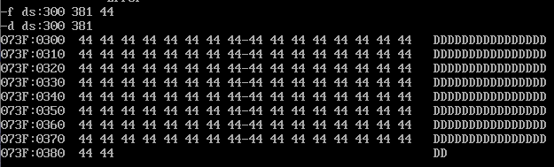
DUMP:
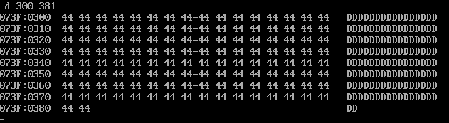
MOV:
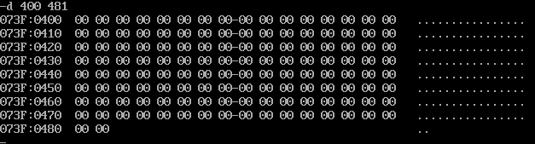
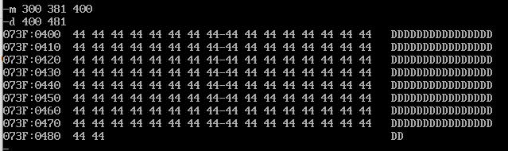

=========================================================
TASK 01 PART B:
FILL
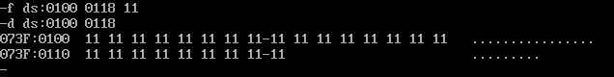
SEARCH

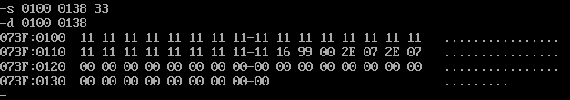
=====================================================
Task 01 part c:
H COMMAND
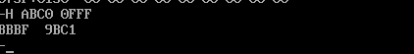
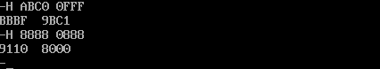
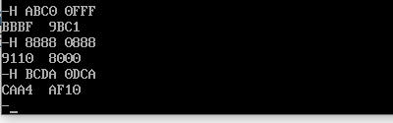
===============================
Task 01 part d
Negative of
0007:
First take binary of
0:0000
0:0000
0:0000
7:0111
Invert the values :
Make 0=1 and 1=0
0=1111
0=1111
0=1111
7:1000
Add 1:
1111 1111 1111 10000 +1= 1111 1111 1111 10001
Convert it to hexadecimal form:
FFF9
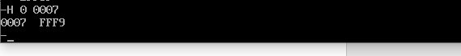

AFCC:
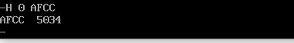
0008:
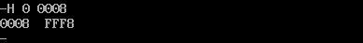
0128:
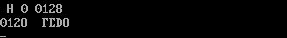
=========================================
Task 01 part e
MOVE 0231
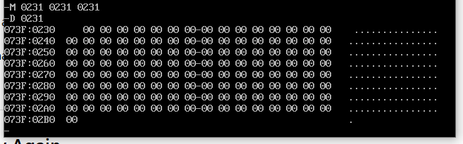

=======================================================
Task 01 part f
Fill and search
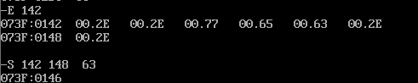
Task 01 part g:
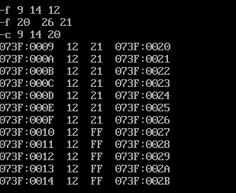
===============================
Task 02:
- ADD [BX+SI+1234],AX

ASSEMBLE CODE
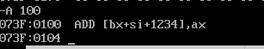
UNASSEMBLE:
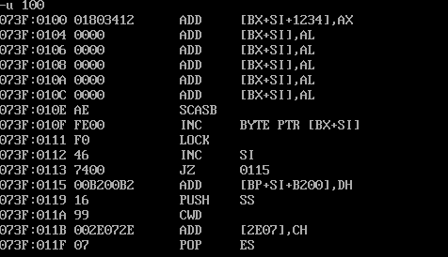
========================
TASK 02 PART B:
Move value 2000 into AX. ● Move the value of AX into DS. ● Move 100 into SI ● Move value 120 into DI ● Move 10 into CX ● Move to AH, the value placed at the address specified by SI ● Move AH value to the value at address specified by DI.
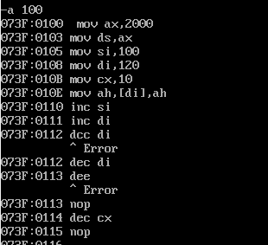
UNASSEMBLED:



